Exercise 1_ Logging Error Messages and Warning Levels
Step :1 Adding Dependencies
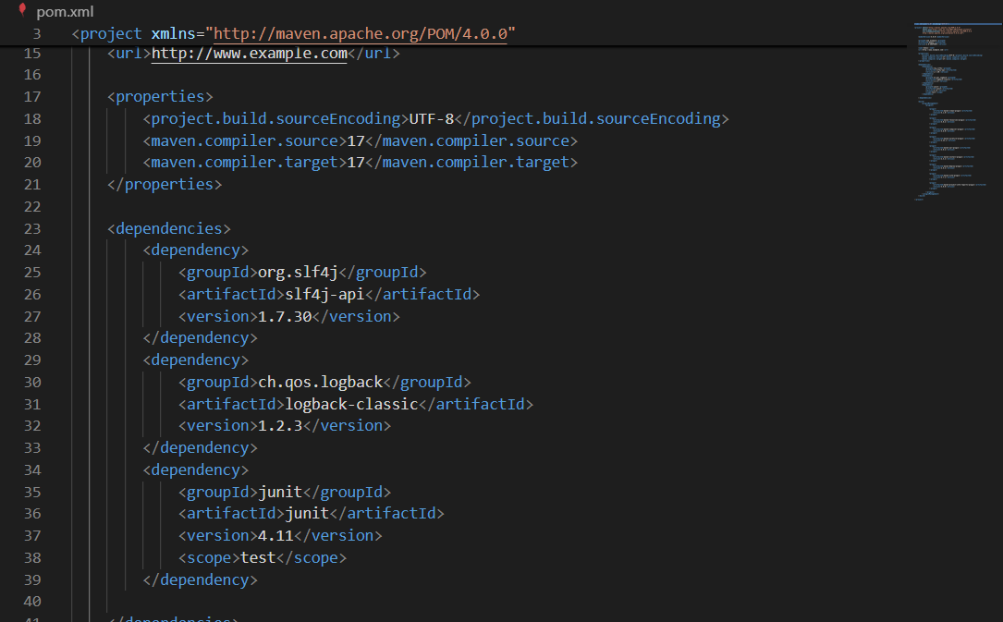

Logging class
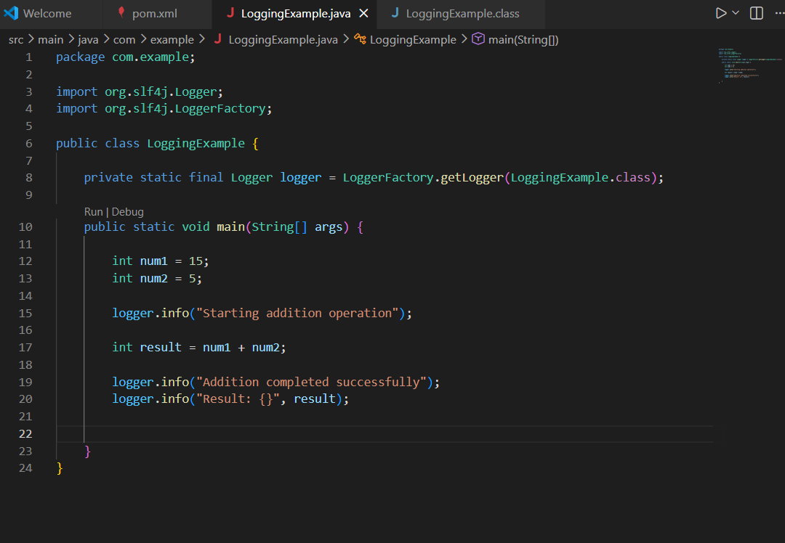

Output
